Class Time:
Names:

Ch. 12: Regression Lab II
Student Learning Outcomes:
- The student will calculate and construct the line of best fit between two variables.
- The student will evaluate the relationship between two variables to determine if that relationship is significant.
Survey 10 textbooks. Collect bivariate data (number of pages in the textbook, the cost of the textbook).
- Complete the table.
Number of Pages | Cost of Textbook

- Which variable should be the dependent variable and which should be the independent variable? Why?

- Graph “number of pages” vs. “cost.” Plot the points on the graph. Label both axes with words. Scale both axes.
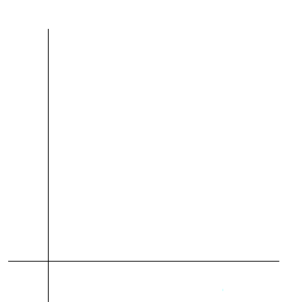
4. Enter your data into your calculator or computer. Write the linear equation below, rounding to 4 decimal places.

a = ___________ b = ___________ correlation = _____________
n = _________

equation: = _______________________________________

Is the correlation significant? Why or why not? (Answer in 1-3 complete sentences.)

5. Answer the following:
  - Predict the total cost of a textbook with 400 pages.

  - Predict the total cost of a textbook with 600 pages.
6. Obtain the graph on your calculator or computer. Sketch the regression line on the graph in 3. above.
Discussion Questions
7. Answer each question in 1-3 complete sentences
- Does the line seem to fit the data? Why?

- What does the correlation imply about the relationship between the distance and the cost?

8.
- Are there any outliers? __________ If so, which point is the outlier? ____________

- Should the outlier, if it exists, be removed? ___________Why or why not?

